J U N G T Y P O L O G Y T E S T

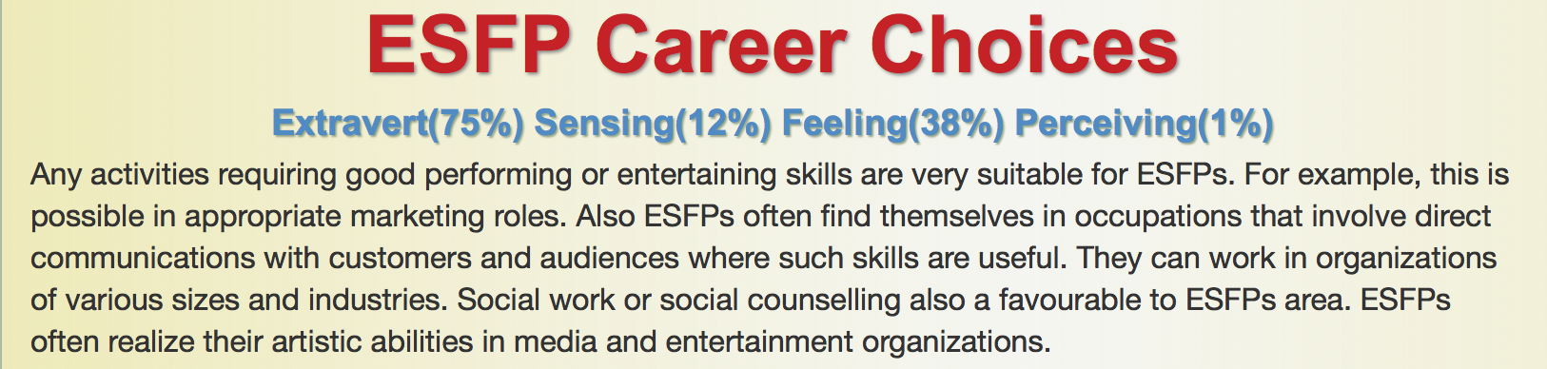

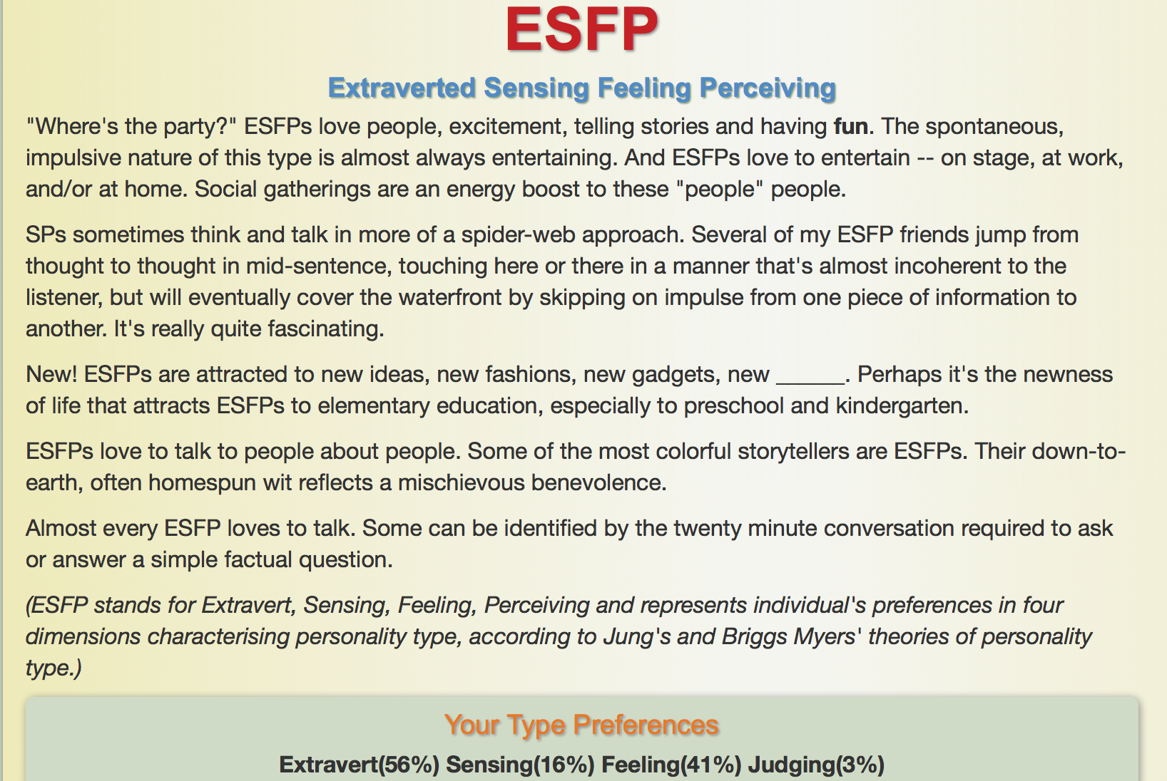

I have done Jung Typology test to evaluate my personality. I believe that the test was relative hard to finish due to ambiguous message on the questions. It does not always have to be one or the other. Also, the questions could have been evaluated differently according to various situations. After a lot of reflecting and evaluating I considered my answers to be the best possible. I found out that I was a ESFP-person, which means that I am an extravert, sensing, feeling and perceiving person. I believe that I know myself pretty well so the outcome of the test did not surprise me.

For me it was funny to read the second paragraph about the spider-web approach because it really suits me. I am very good at making a short story long, it takes a long time for me to get to the point sometimes. I also start to talk about other things so I forget what I was supposed to say from the beginning.

I love to explore new things. It can be everything from travel to sports to courses in school. For me, exploring new things and ideas is the best way of learning. I learn by experiences and mistakes.

My previous work experiences and volunteer experiences have had one thing in common. Interacting with other people. I love to get to know new people. I think that the underlying factor is that I get so much new perspectives and insights in how other people think in situations where I do not agree.

My values in life are honesty, family, drive and commitment, team-oriented and loyalty to relationships. I believe that my personal attributes align with my professional goals in work contexts. I was gladly surprised when I found out that marketing roles fit an ESFP-person when marketing is my major.